**Saint Reports**

**All candidates** **must select a Saint name and write a report, at least one page long, on their chosen Saint.**

When selecting a Confirmation Saint, designate the specific person (i.e. Thomas the Apostle, Thomas Aquinas). The use of one’s own name, if it is also a Saint’s name, can serve to further emphasize the three-fold process of Christian initiation: Baptism, Confirmation and Eucharist. The name chosen must be a blessed or canonized Saint. A canonized Christian Saint is a man or a woman who has displayed heroic virtue and has been recognized by the Church. During Confirmation preparation time, the candidate should research their baptismal name or the new Saint's name they have chosen. After a saint has been selected, type a report, at least **one page in length,** about the Saint's life.

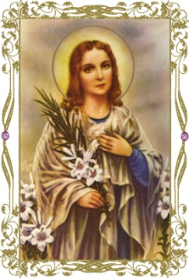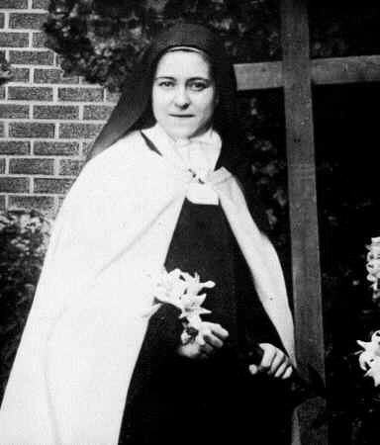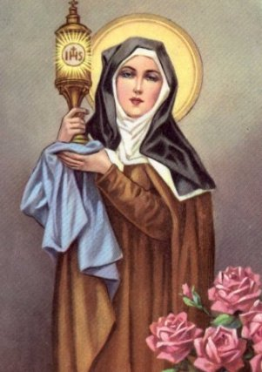

There are numerous online resources for learning about the lives of saints. Here are a few that might help:

[www.americancatholic.org/features/Saints/patrons.aspx](http://www.americancatholic.org/features/Saints/patrons.aspx)

[www.catholic.org/saints](http://www.catholic.org/saints)

[www.ewtn.com/saintsholy](http://www.ewtn.com/saintsholy)

Please include the following topics in your report:

* Who is the Saint? (When and where did he or she live, vocation, family life, job, born/died etc)
* What interesting things have you learned about this Saint through your research?
* Describe one of the miracles attributed to the Saint in order to be canonized(if applicable).
* Why did you select this Saint?
* How is this person a good role model for you to follow as a Catholic?
* List your resources from which you obtained your information (web sites, books, etc.).

All reports are due **February 14, 2018**.